**1. What is the difference between Strong Artificial Intelligence and Weak Artificial Intelligence?**

|  |  |
| --- | --- |
| **Weak AI** | **Strong AI** |
| Narrow application, with very limited scope | Widely applied, with vast scope |
| Good at specific tasks | Incredible human-level intelligence |
| Uses supervised and unsupervised learning to process data | Uses clustering and association to process data |
| E.g., Siri, Alexa, etc. | E.g., Advanced Robotics |

**2. What is Artificial Intelligence?**

[**Artificial Intelligence**](https://intellipaat.com/blog/what-is-artificial-intelligence/) is a field of computer science wherein the cognitive functions of the human brain are studied and tried to be replicated on a machine/system. Artificial Intelligence is today widely used for various applications like computer vision, speech recognition, decision-making, perception, reasoning, cognitive capabilities, and so on.

**3. List some applications of AI.**

* [Natural language processing](https://intellipaat.com/blog/what-is-natural-language-processing/)
* [Chatbots](https://intellipaat.com/blog/how-to-build-an-artificial-intelligence-chatbot/)
* Sentiment analysis
* Sales prediction
* Self-driving cars
* Facial expression recognition
* Image tagging

**4. List the programming languages used in AI.**

* [Python](https://intellipaat.com/blog/tutorial/python-tutorial/what-is-python/)
* [R](https://intellipaat.com/blog/tutorial/r-programming/introduction/)
* Lisp
* Prolog
* [Java](https://intellipaat.com/blog/tutorial/java-tutorial/java-introduction-installation/)

***Wanna become an Expert in AI? Come & join our***[***Artificial Intelligence Course***](https://intellipaat.com/artificial-intelligence-deep-learning-course-with-tensorflow/)***now.***

**5. What are the Examples of AI in real life?**

* **Robo-readers for Grading:**

Many schools, colleges, and institutions are now using [AI applications](https://intellipaat.com/blog/applications-of-artificial-intelligence/) to grade essay questions and assignments on Massive Open Online Courses(MOOCs). In the era of technology, where education is rapidly shifting towards online learning, MOOCs have become a new norm of education. Thousands of assignments are and essay questions are submitted on these platforms on the daily basis,  and grading them by hand is next to impossible.

Robo-readers are used to grade essay questions and assignments based on certain parameters acquired from huge data sets. Thousands of hand-scored essays were fed into the deep Neural Networks of these AI systems to pick up the features of good writing assignments. So, the AI system uses previous results to evaluate the present data.

* **Online Recommendation Systems**

Online recommendations Systems study customer behavior by analyzing their keywords, websites, and the content they watch on the internet. From e-commerce to Social Media websites, everyone is using these recommendation systems to provide a better customer experience.

There are two ways to produce a recommendation list for a customer, collaborative and content-based filtering. In collaborative filtering, the system analyzes the past decisions made by the customer and suggests items that he/she might find interesting. Whereas, content-based filtering finds discrete characteristics of the product or service and suggests similar products and deals that might excite the user. The same process goes for social media apps and other websites.

* **Navigation and Travel**

Google Maps, GPS, and Autopilot on Airplanes are some of the best examples of AI in Navigation and travel. Machine Learning algorithms like Dijkstra’s algorithm are used to find the shortest possible route between two points on the map. However, certain factors are also taken into account including traffic and road blockage to find an optimal route.

* **Fraud Detection**

Machine Learning models process large amounts of banking data and check if there is any suspicious activity or anomalies in the customer transactions. AI applications proved to be more effective than humans in recognizing fraud patterns as they were trained with historical data with millions of transactions.

* **Autonomous Vehicles**

Human error is responsible for more than 90% of accidents happening on the road every year. A technical failure in a vehicle, Roads, and other factors has little contribution to fatal accidents. Autonomous vehicles can reduce these fatal accidents by 90%. Although Self-driving systems require a person to supervise the action and take control of the vehicle in case of emergency, they prove to be very effective when driving on an open highway or parking the vehicle. Also, advancement in technology will further improve the ability to drive in complex situations using high-end AI models and sensors like LIDAR.

***Enroll in a***[***Master’s in Artificial Intelligence in Europe***](https://intellipaat.com/masters-in-artificial-intelligence-europe/)***to get your Master’s degree in AI.***

**6. What is ANN?**

[Artificial Neural Network (ANN)](https://intellipaat.com/blog/what-is-artificial-neural-network/) is a computational model based on the structure of the Biological Neural Network(BNN). The human brain has billions of neurons that collect, process the information, and drive meaningful results out of it. The neurons use electro-chemical signals to communicate and pass the information to other neurons. Similarly, ANN consists of artificial neurons called nodes connected with other nodes forming a complex relationship between the output and the input.

There are three layers in the Artificial Neural Network:

* **Input Layer:** The input layer has neurons that take the input from external sources like files, data sets, images, videos, and sensors. This part of the Neural Network doesn’t perform any computation.  It only transfers the data from the outside world to the Neural Network
* Hidden Layer: The hidden layer receives the data from the input layer and uses it to derive results and train several Machine Learning models. The layer can be further divided into sub-layers that extract features, make decisions, connect with other sources, and predict future actions based on the events that happened.
* Output layer: After processing, the data is transferred to the output layer for delivering it to the outside environment.

**7. Difference between AI, ML, and DL?**

Although [Machine Learning](https://intellipaat.com/blog/what-is-machine-learning/), Artificial Intelligence, and Deep learning are closely related, there are some key differences between them. Artificial Intelligence as an umbrella covers everything related to making a machine think and act like a human. Machine Learning and Deep Learning are subsets of AI and are used to achieve the goals of AI.

Below is the difference between [AI, ML, and DL](https://intellipaat.com/blog/tutorial/artificial-intelligence-tutorial/ai-vs-ml-vs-dl/):

* **Artificial Intelligence:**AI consists of the algorithms and techniques that enable a machine to perform the tasks commonly associated with human intelligence. The AI applications are trained to process large amounts of complex information and right decisions without human intervention. Some of the popular examples of AI applications are chatbots, Autonomous Vehicles, Space rovers, and Simulators for mathematical and scientific purposes.
* **Machine Learning:** Machine Learning is a subset of Artificial Intelligence and is mainly used to improve computer programs through experience and training on different models. There are three main methods of Machine Learning:
  + [**Supervised Learning**](https://intellipaat.com/blog/what-is-supervised-learning/):  In supervised learning, the machine gets the input for twitch the output is already known. After the processing is completed, the algorithm compared the output produced from the original output and measure the degree of errors in it.
  + **Unsupervised Learning:** Here, the instructor has no output or historical labels for the input data. So, the algorithm is expected to figure out the right path and extract the features from the given dataset. The goal is to allow the algorithm to search the data and s some structure in it.
  + **Reinforcement Learning:**  In this method of learning there are three components, the agent, environment, and actions. An agent is a decision-maker whose goal is to choose the right actions and maximize the expected reward within a set timeframe. Reinforcement learning is mainly used in robotics where the machine learns about the environment through trial and error.
* [**Deep Learning**](https://intellipaat.com/blog/tutorial/machine-learning-tutorial/introduction-deep-learning/)**:**In Machine Learning, where the model tends to surrender to environmental changes, Deep Learning adapts to the changes by updating the models based on constant feedback. It’s facilitated by Artificial Neural Networks that mimic the cognitive behavior of the human brain.

***Willing to become a certified AI & ML expert? Enroll in our top***[***AI and Machine Learning courses***](https://intellipaat.com/course-cat/artificial-intelligence-and-machine-learning-courses/)***Now!***

**8. How to choose an algorithm for a problem?**

To solve a problem, there can be multiple [Machine Learning algorithms](https://intellipaat.com/blog/tutorial/machine-learning-tutorial/machine-learning-algorithms/) with different approaches and constraints. However, a generic approach can be applied to most of the problems and find a suitable algorithm. Below are the steps you need to consider while choosing an algorithm:

* **Categorize the Problem**

The first is finding the algorithm, which is to categorize it based on the type of input you have and the output you want from it. If the data is labeled, it’s a problem for supervised learning. If the data is not labeled, then it’s an unsupervised learning problem. At last, if the problem aims to optimize a model, then it’s a reinforcement learning problem.

Similarly, you can categorize a problem based on the outcome you want from the algorithm. If the output is expected to be numerical then it’s a regression problem. Is class is the output of a model, it’s a classification problem, and grouping of the input values can be categorized as the clustering problems.

* **Understanding the Data**

Data plays an important role in the process of selecting the right algorithm for your problem. This is because, some algorithms can process tons of data, while some work better with smaller samples. Analyzing and transforming your data will also help you to know the constraints and the challenges you t=want to overcome while solving the problem.

* **Find the available Algorithms**

Identify the available algorithms you can apply for solving the problem in a reasonable timeframe. Some of the factors that may affect your choice of the right algorithm include the accuracy of the algorithm, complexity, scalability interpretability, build & training time, space, and the time it takes to solve the problem.

* **Implement the Algorithm**

After selecting the algorithm, you have to make an evaluation criteria by carefully selecting the testing values and subgroups of the datasets. Also, check the time taken by each algorithm to solve the problem. The algorithm that provides accurate results in the given time while acquiring less space, would be the best algorithm for your problem.

### ****9. What is Tower of Hanoi?****

Tower of Hanoi is a mathematical puzzle that shows how recursion might be utilized as a device in building up an algorithm to take care of a specific problem. Using a decision tree and a breadth-first search (BFS) algorithm in AI, we can solve the Tower of Hanoi.

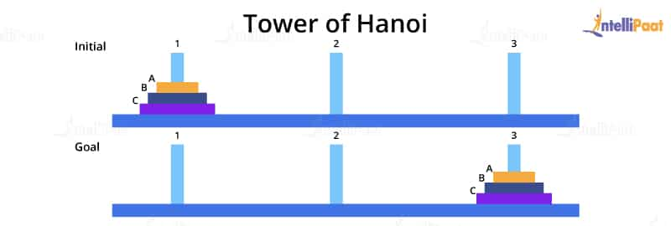

**Go through the**[**Artificial Intelligence Course in London**](https://intellipaat.com/artificial-intelligence-course-london/)**to get a clear understanding of Artificial Intelligence!**

### ****10. What is Turing test?****

The Turing test is a method to test a machine’s ability to match human-level intelligence. A machine is used to challenge human intelligence, and when it passes the test it is considered intelligent. Yet a machine could be viewed as intelligent without sufficiently knowing how to mimic a human.

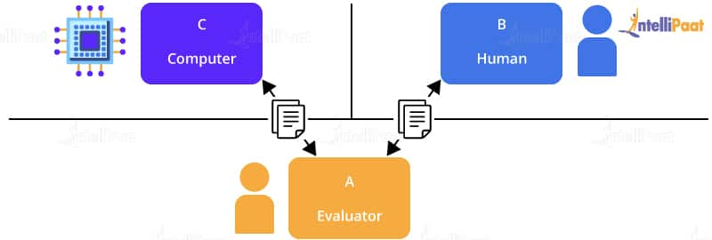

### ****11. What is an expert system? What are the characteristics of an expert system?****

An [expert system](https://intellipaat.com/blog/expert-system-in-ai/) is an Artificial Intelligence program that has expert-level knowledge about a specific area and how to utilize its information to react appropriately. These systems have the expertise to substitute a human expert. Their characteristics include:

* High performance
* Adequate response time
* Reliability
* Understandability

### ****12. List the advantages of an expert system.****

* Consistency
* Memory
* Diligence
* Logic
* Multiple expertise
* Ability to reason
* Fast response
* Unbiased in nature

### ****13. What is an A* algorithm search method?****

A* is a computer algorithm that is extensively used for the purpose of finding the path or traversing a graph in order to find the most optimal route between various points called the nodes.

### ****14. What is a breadth-first search algorithm?****

A breadth-first search (BFS) algorithm, used for searching tree or graph data structures, starts from the root node, then proceeds through neighboring nodes, and further moves toward the next level of nodes.

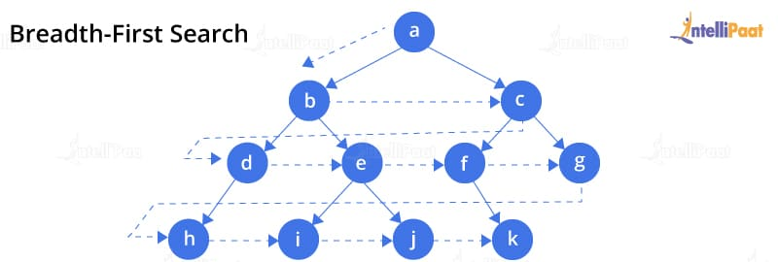

Till the arrangement is found, it produces one tree at any given moment. As this pursuit can be executed utilizing the FIFO (first-in, first-out) data structure, this strategy gives the shortest path to the solution.

[](https://intellipaat.com/post-graduate-certification-big-data-analytics/)

### ****15. What is a depth-first search algorithm?****

Depth-first search (DFS) is based on LIFO (last-in, first-out). A recursion is implemented with the LIFO stack data structure. Thus, the nodes are in a different order than in BFS. The path is stored in each iteration from root to leaf nodes in a linear fashion with space requirement.

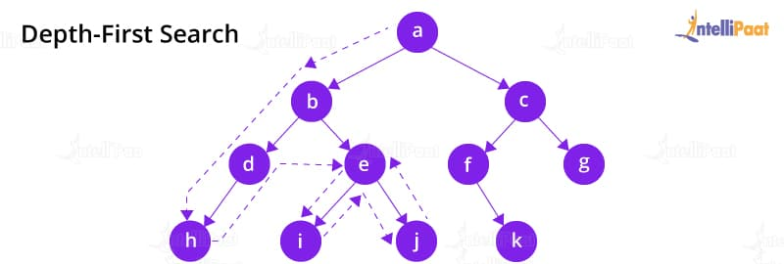

**Learn more about Artificial Intelligence from this**[**Artificial Intelligence Training in New York**](https://intellipaat.com/artificial-intelligence-course-new-york/)**to get ahead in your career!**

### ****16. What is a bidirectional search algorithm?****

In a bidirectional search algorithm, the search begins forward from the beginning state and in reverse from the objective state. The searches meet to identify a common state. The initial state is linked with the objective state in a reverse way. Each search is done just up to half of the aggregate way.

### ****17. What is an iterative deepening depth-first search algorithm?****

The repetitive search processes of level 1 and level 2 happen in this search. The search processes continue until the solution is found. Nodes are generated until a single goal node is created. The stack of nodes is saved.

### ****18. What is a uniform cost search algorithm?****

The uniform cost search performs sorting in increasing the cost of the path to a node. It expands the least cost node. It is identical to BFS if each iteration has the same cost. It investigates ways in the expanding order of cost.

**Interested in learning more about Artificial Intelligence? Click here:**[***Artificial Intelligence Training in Sydney***](https://intellipaat.com/artificial-intelligence-course-sydney/)**!**

### ****19. How are game theory and AI related?****

AI system uses game theory for enhancement; it requires more than one participant which narrows the field quite a bit. The two fundamental roles are as follows:

* Participant design: Game theory is used to enhance the decision of a participant to get maximum utility.
* Mechanism design: Inverse game theory designs a game for a group of intelligent participants, e.g., auctions.

## Artificial Intelligence Interview Questions for 1-2 years of experienced

### ****20. Explain Alpha–Beta pruning.****

Alpha–Beta pruning is a search algorithm that tries to reduce the number of nodes that are searched by the minimax algorithm in the search tree. It can be applied to ‘n’ depths and can prune the entire subtrees and leaves.

### ****21. What is a fuzzy logic?****

Fuzzy logic is a subset of AI; it is a way of encoding human learning for artificial processing. It is a form of many-valued logic. It is represented as IF-THEN rules.

### ****22. List the applications of fuzzy logic.****

* Facial pattern recognition
* Air conditioners, washing machines, and vacuum cleaners
* Antiskid braking systems and transmission systems
* Control of subway systems and unmanned helicopters
* Weather forecasting systems
* Project risk assessment
* Medical diagnosis and treatment plans
* Stock trading

### ****23. What is a partial-order planning?****

A problem has to be solved in a sequential approach to attain the goal. The partial-order plan specifies all actions that need to be undertaken but specifies an order of the actions only when required.

***Become a master of Artificial Intelligence by going through this online***[***Artificial Intelligence Course in Toronto***](https://intellipaat.com/artificial-intelligence-course-toronto/)***!***

### ****24. What is FOPL?****

First-order predicate logic is a collection of formal systems, where each statement is divided into a subject and a predicate. The predicate refers to only one subject, and it can either modify or define the properties of the subject.

### ****25. What is the difference between inductive, deductive, and abductive Machine Learning?****

|  |  |  |
| --- | --- | --- |
| **Inductive Machine Learning** | **Deductive Machine Learning** | **Abductive Machine Learning** |
| Learns from a set of instances to draw the conclusion | Derives the conclusion and then improves it based on the previous decisions | It is a Deep Learning technique where conclusions are derived based on various instances |
| Statistical Machine Learning such as KNN (K-nearest neighbor) or SVM (Support Vector Machine) | Machine Learning algorithm using a decision tree | Deep neural networks |
| A ⋀ B ⊢ A → B (Induction) | A ⋀ (A → B) ⊢ B (Deduction) | B ⋀ (A → B) ⊢ A (Abduction) |

### ****26. List the different algorithm techniques in Machine Learning.****

Here are some of the most commonly used Machine Learning Algorithms

* Supervised Learning
* Unsupervised Learning
* Semi-supervised Learning
* Reinforcement Learning
* Transduction
* Learning to Learn

### ****27. What is Deep Learning?****

Deep Learning is a subset of Machine Learning which is used to create an artificial multi-layer neural network. It has self-learning capabilities based on previous instances, and it provides high accuracy.

***Get certified from the top***[***Artificial Intelligence Course in Singapore***](https://intellipaat.com/artificial-intelligence-course-singapore/)***now!***

### ****28. Differentiate between supervised, unsupervised, and reinforcement learning.****

|  |  |  |  |
| --- | --- | --- | --- |
| **Differentiation Based on** | **Supervised Learning** | **Unsupervised Learning** | **Reinforcement Learning** |
| Features | The training set has both predictors and predictions. | The training set has only predictors. | It can establish state-of-the-art results on any task. |
| Algorithms | Linear and logistic regression, support vector machine, and Naive Bayes | K-means clustering algorithm and dimensionality reduction algorithms | Q-learning, state-action-reward-state-action (SARSA), and Deep Q Network (DQN) |
| Uses | Image recognition, speech recognition, forecasting, etc. | Preprocessing data, pre-training supervised learning algorithms, etc. | Warehouses, inventory management, delivery management, power system, financial systems, etc. |

### ****29. Differentiate between parametric and non-parametric models.****

|  |  |  |
| --- | --- | --- |
| **Differentiation Based on** | **Parametric Model** | **Non-parametric Model** |
| Features | A finite number of parameters to predict new data | Unbounded number of parameters |
| Algorithm | Logistic regression, linear discriminant analysis, perceptron, and Naive Bayes | K-nearest neighbors, decision trees like CART and C4.5, and support vector machines |
| Benefits | Simple, fast, and less data | Flexibility, power, and performance |
| Limitations | Constrained, limited complexity, and poor fit | More data, slower, and overfitting |

### ****30. Name a few Machine Learning algorithms you know.****

* Logistic regression
* Linear regression
* [**Decision trees**](https://intellipaat.com/blog/decision-tree-algorithm-in-machine-learning/)
* Support vector machines
* Naive Bayes, and so on

***Learn more about Machine Learning algorithms from our***[***Artificial Intelligence Tutorial***](https://intellipaat.com/blog/tutorial/artificial-intelligence-tutorial/)***!***

### ****31. What is Naive Bayes?****

Naive Bayes Machine Learning algorithm is a powerful algorithm for predictive modeling. It is a set of algorithms with a common principle based on the Bayes Theorem. The fundamental Naive Bayes assumption is that each feature makes an independent and equal contribution to the outcome.

### ****32. What is a Backpropagation Algorithm?****

[Backpropagation](https://intellipaat.com/blog/tutorial/artificial-intelligence-tutorial/back-propagation-algorithm/) is a Neural Network algorithm that is mainly used to process noisy data and detect unrecognized patterns for better clarification. It’s a full-state algorithm and has an iterative nature. As an ANN algorithm, Backpropagation has three layers, Input, hidden, and output layer.

The input layers receive the input values and constraints from the user or the outside environment. After that, the data goes to the Hidden layer where the processing is done. At last, the processed data is transformed into some values or patterns that can be shared using the output layer.

Before processing the data, the following values should be there with the algorithm:

* **Dataset:** The dataset which is going to be used for training a model.
* **Target Attributes**: Output values that an algorithm should achieve after processing the data.
* **Weights**: In a neural network, weights are the parameters that transform input data within the hidden layer.
* **Biases**: At each node, some values called bias are added to the sum calculated(except input nodes).

Backpropagation is simple ANN algorithm that follows a standard approach for training ML models. It doesn’t require high computational performance and is widely used in speed recognition, image processing, and optical character recognition(OCR).

***Get your Master’s Degree in AI with Job Assistance by enrolling in***[***Master’s in Artificial Intelligence in Germany***](https://intellipaat.com/masters-in-artificial-intelligence-germany/)***.***

### ****33. How route weights are optimized to reduce the error in the model?****

Weights in AI determine how much influence the input is going to have on the output. In [neural networks](https://intellipaat.com/blog/tutorial/machine-learning-tutorial/neural-network-tutorial/), algorithms use weights to process the information and train the model. The output is expected to be the same as the target attributes.

However, the output may have some errors, which need to be rectified to produce the exact output. For example, in the Backpropagation algorithm when there is an error in the output, the algorithm will backpropagate to the hidden layer and reroute the weights to get an optimized output.

### ****34. What is perceptron in Machine Learning?****

Perceptron is an algorithm that is able to simulate the ability of the human brain to understand and discard; it is used for the supervised classification of the input into one of the several possible non-binary outputs.

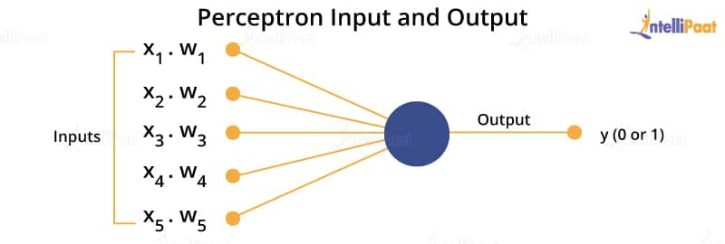

***Wish to achieve a complete knowledge of Artificial Intelligence? Enroll in***[***Artificial Intelligence Training at Hyderabad***](https://intellipaat.com/artificial-intelligence-course-hyderabad/)***now!***

### ****35. List the extraction techniques used for dimensionality reduction.****

* Independent component analysis
* Principal component analysis
* Kernel-based principal component analysis

### ****36. Is KNN different from K-means Clustering?****

|  |  |
| --- | --- |
| **KNN** | **K-means Clustering** |
| Supervised | Unsupervised |
| Classification algorithms | Clustering algorithms |
| Minimal training model | Exhaustive training model |
| Used in the classification and regression of the known data | Used in population demographics, market segmentation, social media trends, anomaly detection, etc. |

### ****37. What is ensemble learning?****

Ensemble learning is a computational technique in which classifiers or experts are strategically formed and combined. It is used to improve the classification, prediction, function approximation, etc. of a model.

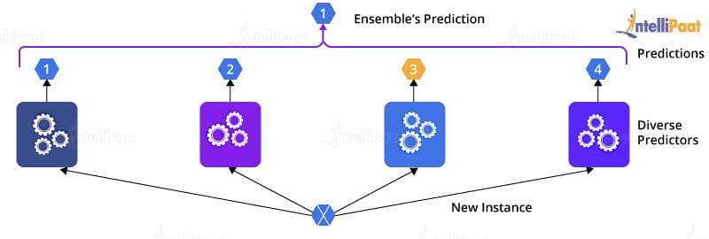

***Are you interested in learning AI? Enroll in the***[***Artificial Intelligence Course in Bangalore***](https://intellipaat.com/artificial-intelligence-course-bangalore/)***and learn from experts!***

### ****38. List the steps involved in Machine Learning.****

* Data collection
* Data preparation
* Choosing an appropriate model
* Training the dataset
* Evaluation
* Parameter tuning
* Predictions

### ****39. What is a hash table?****

A hash table is a data structure that is used to produce an associative array which is mostly used for database indexing.

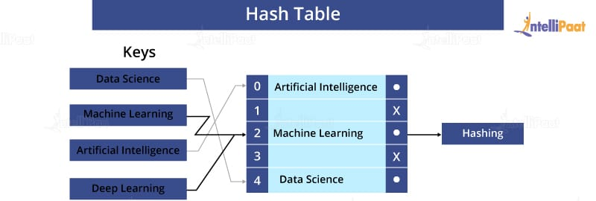

### ****40. What is regularization in Machine Learning?****

Regularization comes into the picture when a model is either overfit or underfit. It is basically used to minimize the error in a dataset. A new piece of information is fit into the dataset to avoid fitting issues.

### ****41. What are the components of relational evaluation techniques?****

* [**Data acquisition**](https://intellipaat.com/blog/tutorial/data-science-tutorial/data-acquisition/)
* Ground truth acquisition
* Cross-validation technique
* Query type
* Scoring metric
* Significance test

***These are described in detail in our***[***AI Community***](https://intellipaat.com/community/ai-and-deep-learning)***!***

### ****42. What is model accuracy and model performance?****

Model accuracy, a subset of model performance, is based on the model performance of an algorithm. Whereas, model performance is based on the datasets we feed as inputs to the algorithm.

### ****43. Define F1 score.****

F1 score is the weighted average of precision and recall. It considers both false positive and false negative values into account. It is used to measure a model’s performance.

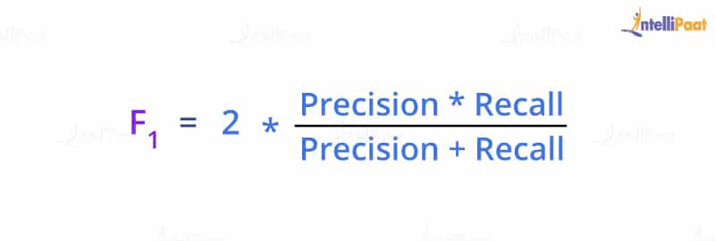

### ****44. List the applications of Machine Learning.****

* Image, speech, and face detection
* Bioinformatics
* Market segmentation
* Manufacturing and inventory management
* Fraud detection, and so on

### ****45. Can you name three feature selection techniques in Machine Learning?****

1. Univariate Selection
2. Feature Importance
3. Correlation Matrix with Heatmap

### ****46. What is a recommendation system?****

A recommendation system is an information filtering system that is used to predict user preference based on choice patterns followed by the user while browsing/using the system.

## Artificial Intelligence Interview Questions for Experienced

### ****47. What methods are used for reducing dimensionality?****

Dimensionality reduction is the process of reducing the number of random variables. We can reduce dimensionality using techniques such as missing values ratio, low variance filter, high correlation filter, random forest, principal component analysis, etc.

### ****48. List different methods for sequential supervised learning.****

* Sliding window methods
* Recurrent sliding windows methods
* Hidden Markov models
* Maximum entropy Markov models
* Conditional random fields
* Graph transformer networks

### ****49. What are the advantages of neural networks?****

* Require less formal statistical training
* Have the ability to detect nonlinear relationships between variables
* Detect all possible interactions between predictor variables
* Availability of multiple training algorithms

### ****50. What is Bias–Variance tradeoff?****

Bias error is used to measure how much on average the predicted values vary from the actual values. In case a high-bias error occurs, we have an under-performing model.

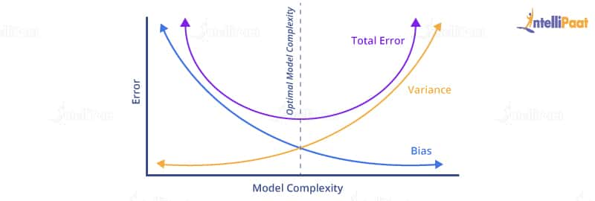

Variance is used to measure how the predictions made on the same observation differ from each other. A high-variance model will overfit the dataset and perform badly on any observation.

[](https://intellipaat.com/data-science-architect-masters-program-training/)

### ****51. What is TensorFlow?****

[TensorFlow](https://intellipaat.com/blog/what-is-tensorflow/) is an open-source Machine Learning library. It is a fast, flexible, and low-level toolkit for doing complex algorithms and offers users customizability to build experimental learning architectures and to work on them to produce desired outputs.

### ****52. How to install TensorFlow?****

TensorFlow Installation Guide:

CPU: pip install tensorflow-cpu

GPU: pip install tensorflow-gpu

### ****53. What are the TensorFlow objects?****

1. Constants
2. Variables
3. Placeholder
4. Graph
5. Session

### ****54. What is a cost function?****

A cost function is a scalar function that quantifies the error factor of the neural network. Lower the cost function better the neural network. For example, while classifying the image in the MNIST dataset, the input image is digit 2, but the neural network wrongly predicts it to be 3.

### ****55. List different activation neurons or functions.****

1. Linear neuron
2. Binary threshold neuron
3. Stochastic binary neuron
4. Sigmoid neuron
5. Tanh function
6. Rectified linear unit (ReLU)

### ****56. What are the hyper parameters of ANN?****

* **Learning rate:** The learning rate is how fast the network learns its parameters.
* **Momentum:** It is a parameter that helps to come out of the local minima and smoothen the jumps while gradient descent.
* **Number of epochs:**The number of times the entire training data is fed to the network while training is referred to as the number of epochs. We increase the number of epochs until the validation accuracy starts decreasing, even if the training accuracy is increasing (overfitting).

### ****57. What is vanishing gradient?****

As we add more and more hidden layers, backpropagation becomes less useful in passing information to the lower layers. In effect, as information is passed back, the gradients begin to vanish and become small relative to the weights of the network.

### ****58. What are dropouts?****

Dropout is a simple way to prevent a neural network from overfitting. It is the dropping out of some of the units in a neural network. It is similar to the natural reproduction process, where the nature produces offsprings by combining distinct genes (dropping out others) rather than strengthening the co-adapting of them.

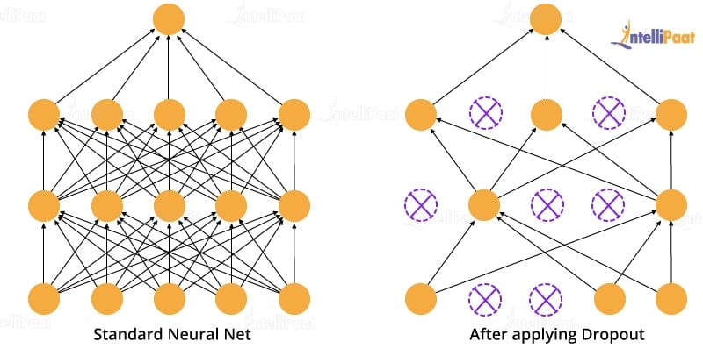

### ****59. Define LSTM.****

[Long short-term memory](https://intellipaat.com/blog/what-is-lstm/) (LSTM) is explicitly designed to address the long-term dependency problem, by maintaining a state of what to remember and what to forget.

### ****60. List the key components of LSTM.****

* Gates (forget, Memory, update, and Read)
* Tanh(x) (values between −1 and 1)
* Sigmoid(x) (values between 0 and 1)

### ****61. List the variants of RNN.****

* LSTM: Long Short-term Memory
* GRU: Gated Recurrent Unit
* End-to-end Network
* Memory Network

### ****62. What is an autoencoder? Name a few applications.****

An autoencoder is basically used to learn a compressed form of the given data. A few applications of an autoencoder are given below:

1. Data denoising
2. Dimensionality reduction
3. Image reconstruction
4. Image colorization

***Get your Master’s Degree in AI with Job Assistance by enrolling in***[***Master’s in Artificial Intelligence in India***](https://intellipaat.com/masters-in-artificial-intelligence-india/)***.***

### ****63. What are the components of the generative adversarial network (GAN)? How do you deploy it?****

**Components of GAN:**

* Generator
* Discriminator

**Deployment Steps:**

* Train the model
* Validate and finalize the model
* Save the model
* Load the saved model for the next prediction

### ****64. What are the steps involved in the gradient descent algorithm?****

Gradient descent is an optimization algorithm that is used to find the coefficients of parameters that are used to reduce the cost function to a minimum.

**Step 1**: Allocate weights (x,y) with random values and calculate the error (SSE)

**Step 2**: Calculate the gradient, i.e., the variation in SSE when the weights (x,y) are changed by a very small value. This helps us move the values of x and y in the direction in which SSE is minimized

**Step 3**: Adjust the weights with the gradients to move toward the optimal values where SSE is minimized

**Step 4**: Use new weights for prediction and calculating the new SSE

**Step 5**: Repeat Steps 2 and 3 until further adjustments to the weights do not significantly reduce the error

### ****65. What do you understand by session in TensorFlow?****

**Syntax: Class Session**

It is a class for running TensorFlow operations. The environment is encapsulated in the session object wherein the operation objects are executed and Tensor objects are evaluated.

# Build a graph

x = tf.constant(2.0)

y = tf.constant(5.0)

z = x * y

# Launch the graph in a session

sess = tf.Session()

# Evaluate the tensor `z`

print(sess.run(z))

### ****66. What do you mean by TensorFlow cluster?****

TensorFlow cluster is a set of ‘tasks’ that participate in the distributed execution of a TensorFlow graph. Each task is associated with a TensorFlow server, which contains a ‘master’ that can be used to create sessions and a ‘worker’ that executes operations in the graph. A cluster can also be divided into one or more ‘jobs’, where each job contains one or more tasks.

[](https://intellipaat.com/post-graduate-certification-big-data-analytics/)

### ****67. How to run TensorFlow on Hadoop?****

To use HDFS with TensorFlow, we need to change the file path for reading and writing data to an HDFS path. For example:

filename_queue = tf.train.string_input_producer([

"hdfs://namenode:8020/path/to/file1.csv",

"hdfs://namenode:8020/path/to/file2.csv",

])

### ****68. What are intermediate tensors? Do sessions have lifetime?****

The intermediate tensors are tensors that are neither inputs nor outputs of the Session.run() call, but are in the path leading from the inputs to the outputs; they will be freed at or before the end of the call.

Sessions can own resources, few classes like tf.Variable, tf.QueueBase, and tf.ReaderBase, and they use a significant amount of memory. These resources (and the associated memory) are released when the session is closed, by calling tf.Session.close.

**69. What is the lifetime of a variable?**

When we first run the tf.Variable.initializer operation for a variable in a session, it is started. It is destroyed when we run the tf.Session.close operation.

**70. Is it possible to solve logical inference in propositional logic?**

Yes, logical inference can easily be solved in propositional logic by making use of three concepts:

* Logical equivalence
* Process satisfaction
* Validation checking

**71. How does face verification work?**

Face verification is used by a lot of popular firms these days. Facebook is famous for its usage of DeepFace for its face verification needs.

There are four main things you must consider when understanding how to face verification works:

* **Input**: Scanning an image or a group of images
* **Process**:
  + Detection of facial features
  + Feature comparison and alignment
  + Key pattern representation
  + Final image classification
* **Output**: Face representation, which is a result of a multilayer neural network
* **Training data**: Involves the usage of thousands of millions of images

The implementation of face verification in Python requires special libraries such as glob, NumPy, OpenCV(cv2), and face_recognisation. Among them, OpenCV is one of the most widely used libraries for computer vision and image processing.

OpenCV is a beginner-friendly, cross-platform python library that is mainly used for real-time image and video processing applications. WithOpenCV, you can create applications used for object detection, facial recognition, and object tracking. It can also be used to extract the facial features and identify unique patterns for face verification.

***Thinking of getting a master’s degree in AI? Enroll in***[***Master’s in Artificial Intelligence in Ireland***](https://intellipaat.com/masters-in-artificial-intelligence-ireland/)***.***

**72. What are some of the algorithms used for hyperparameter optimization?**

There are many algorithms that are used for hyperparameter optimization, and the following are the three main ones that are widely used:

* Bayesian optimization
* Grid search
* Random search

**73. What is overfitting? How is overfitting fixed?**

Overfitting is a situation that occurs in statistical modeling or Machine Learning where the algorithm starts to over-analyze data, thereby receiving a lot of noise rather than useful information. This causes low bias but high variance, which is not a favorable outcome.

Overfitting can be prevented by using the below-mentioned methods:

* Early stopping
* Ensemble models
* Cross-validation
* Feature removal
* Regularization

**74. How is overfitting avoided in neural networks?**

Overfitting is avoided in neural nets by making use of a regularization technique called ‘dropout.’

By making use of the concept of dropouts, random neurons are dropped when the neural network is being trained to use the model doesn’t overfit. If the dropout value is too low, it will have a minimal effect. If it is too high, the model will have difficulty in learning.